1. Seq2Seq

* LSTM - set initial state for decoder

[How to implement Seq2Seq LSTM Model in Keras #ShortcutNLP](https://towardsdatascience.com/how-to-implement-seq2seq-lstm-model-in-keras-shortcutnlp-6f355f3e5639)

* LSTM - return_sequences, return_state

[Difference Between Return Sequences and Return States for LSTMs in Keras](https://machinelearningmastery.com/return-sequences-and-return-states-for-lstms-in-keras/)

* LSTM - repeat _vector & time distributed (repeat the hidden state of last time step of encoder to the initial state of decoder and as input)

[How to Develop an Encoder-Decoder Model with Attention in Keras](https://machinelearningmastery.com/encoder-decoder-attention-sequence-to-sequence-prediction-keras/)

* Seq2Seq time series forecasting

<https://github.com/guillaume-chevalier/seq2seq-signal-prediction>

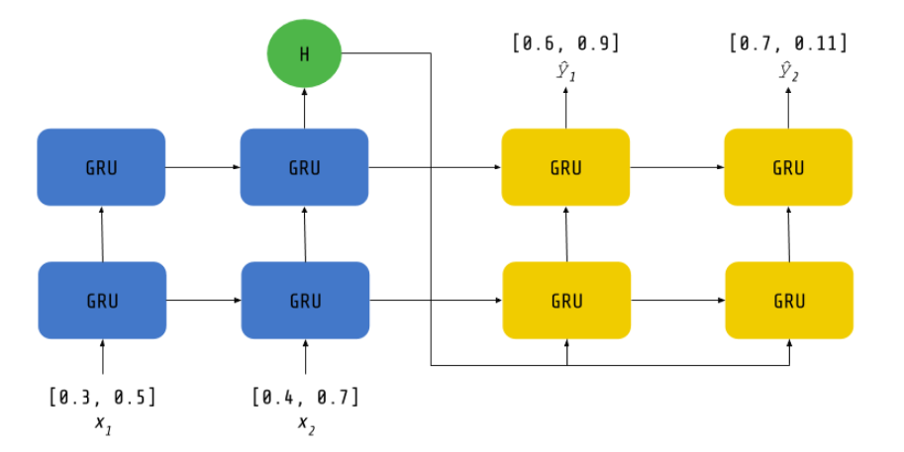

* Attention

[Intuitive Understanding of Attention Mechanism in Deep Learning](https://towardsdatascience.com/intuitive-understanding-of-attention-mechanism-in-deep-learning-6c9482aecf4f)

Code - the hidden state to attention

[Attention in RNNs - Data Driven Investor](https://medium.com/datadriveninvestor/attention-in-rnns-321fbcd64f05)

[A Comprehensive Guide to Attention Mechanism in Deep Learning](https://www.analyticsvidhya.com/blog/2019/11/comprehensive-guide-attention-mechanism-deep-learning/)

1. Transformer

* <https://colab.research.google.com/github/tensorflow/docs/blob/master/site/en/tutorials/text/transformer.ipynb#scrollTo=fd1NWMxjfsDd>